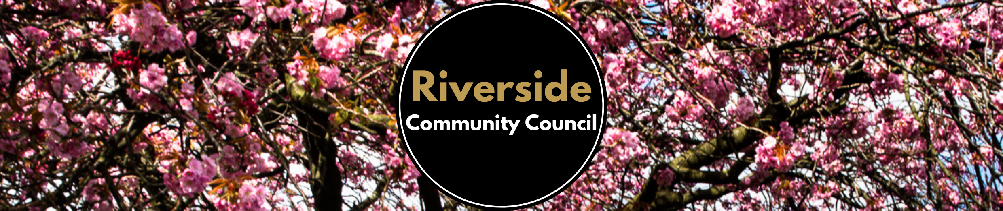
Letter to Councillors and Stirling Council regarding Waste Transformation Programme 29th June 2020

Good Afternoon,

I am writing on behalf of the Riverside community regarding the Waste Transformation Programme that was brought to our attention by a resident on Wednesday 24th June.
Some residents in our community have voiced a number of concerns regarding this programme which we wanted to bring to your attention before the meeting on Tuesday.
It is felt that four weeks is too long between grey bin collections, particularly for families and homes with multiple occupancies.
It is feared that excess waste may:
-be put in other households bins
-be put in bags on the street where birds and vermin would have access and therefore lead to health and safety issues.
-lead to further fly-tipping, which has already been reported during coronavirus lockdown, along our riverbank.
-result in additional fuel consumption due to travelling to the recycling centre more often, which is counterproductive to Stirling Council's environmental aims.
Other general concerns raised are regarding how households are being considered where:
- medical needs produce extra waste
- disabilities prohibit being able to travel to the recycling centre and those
- a low income prohibits paying for a brown bin permit or transport to access the recycling centre.
- they already use communal bins and how the impact of this change will affect them
We appreciate that Stirling Council has no legal obligation to provide garden waste collection. However, we would be interested in finding out how Stirling Council plans to support any changes it decides on with regards to community engagement activities focusing on environmental and recycling education, for example, composting, sustainable living and waste reduction.
Lastly, we feel that the speed with which
i) this potentially very disruptive program has been announced and
ii) subsequent meetings have been scheduled, to be unreasonable, and we feel that Stirling Council has not allowed sufficient time to communicate and consult with communities in Stirling.
We request you consider our concerns prior to the meeting and we look forward to hearing about further on this matter.
Thank you for your help,

